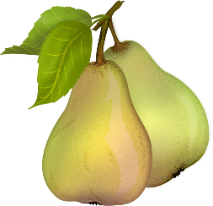
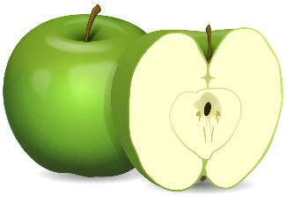
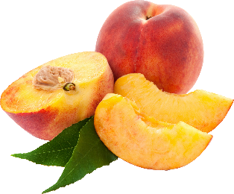
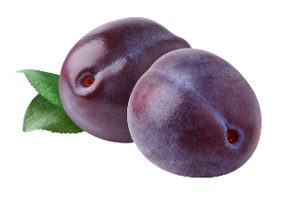

Watering:
Deep soak, meaning give several gallons of water per tree. During Spring- 2 times per week, Summer-3 times per week, and Fall-2 times per week. Winter just water occasionally as needed. Take into account your soil type and adjust this schedule accordingly. Slower draining, clay soils need water less often than quick draining sandy soils. Be sure the tree is getting watered all the way around the base during the first 3 years after planting. This helps the roots grow outward. These are general instructions, so please remember to adjust accordingly depending on the weather. During hot weather, plants require more water than during cooler months.
Fertilizing:
Fertilize your trees 3 times per year. There's an easy way to remember when by holidays: Valentine's Day, Memorial Day, and Labor Day. Regular fertilizing will result in larger crops and tastier fruit. We recommend our E.B. Stone Organic Citrus and Fruit Tree Food or Master Nursery Fruit Tree and Vine Food.
Maintenance:
Paint your main trunk or trunks up as far as possible with tree trunk paint. You can even paint the branches where sun may be hitting them. The purpose of this is to keep the bark from getting sunburnt and peeling off. When the bark peels off, it leaves the tree open to bad insects like borers, which bore into the wood of the tree and can kill the top or the entire tree. Repaint your trees at least once a year. We recommend during winter when the tree is dormant, because it's easier to paint at that time.
Prune and thin your trees every winter. We have pruning workshops every January about how to do this. Check with us in December for dates and times. You can also top your trees in summer or early fall, after harvesting the fruit. Any time you cut a branch bigger around than your thumb off the main trunk, be sure to seal it up with Pruning Seal. This will keep insects from getting in.

